**THE EVALUATION OF CLINICAL PRIVILEGE IMPLEMENTATION OF CLINICAL NURSES: A MINI PROJECT IN MILITARY HOSPITAL IN JAKARTA**

Bela Pertiwi1*, Rr Tutik Sri Hariyati2, Siti Anisah 3

1. Postgraduate Student, Faculty of Nursing, Universitas Indonesia
2. Department Basic Science & Fundamental Nursing, Faculty of Nursing, Universitas Indonesia
3. Head of Nurse Inpatient Hospital X, Jakarta, Indonesia

*\*e-mail:* [*belapertiwi859@yahoo.com*](mailto:belapertiwi859@yahoo.com)

**Abstract**

The nurse's competence provides benefits to improve the quality of nursing care. This research aims to provide recommendations for monitoring and evaluating Hospital. This research employed a mini project method. The implementation of the provisions analysis employed Strengths-Weakness-Opportunity-Threats (SWOT) analysis. It identifies the root of the problem through fish-bone analysis, determination, solutions, and evaluation. Preliminary assessment employed total sampling, and 84 nurses were involved. Furthermore, this research employed evaluation of the clinical privilege implementation by involving 23 nurses and structured interviews by involving 6 people at the Jakarta Military Hospital. The result revealed that clinical privilege is not completely implemented because the ratio of nurses to patients is not ideal. 28% of nursing actions carried out by Clinical Nurse I–Clinical Nurse III nurses are under the authority of clinical seniors. This research recommends that manager improve the function of monitoring and evaluations in implementing clinical privilege based on the delineation of clinical privilege applied by the hospital; and improve the number of professional nurses at the Jakarta Military Hospital.

Keywords: authority, clinical, evaluation, monitoring, nursing, observation

**INTRODUCTION**

To realize the good quality of health services, it requires the nurse manager’s support to possibly perform good managerial roles and functions 1,3. Nurse management is a process of planning, organizing, staffing, actuating, and controlling which are related to each other 4. The role of nurses’ manager cannot be separated by the process of management, including applying attention to the material resources or human resources of nursing.

The success of nurse resources must be supported by the nurse professionalism 5. One of the supports to nurse professionalism is by developing nurses’ carrier. The policy about carrier ladder in Indonesia is arranged in PMK No. 40, 2017, which states that competence level in carrier ladder, provides accountability and ethical value based on nurse privilege imitation in giving nursing care. It is also stated in National Standard of Hospital Accreditation that nursing care to the patients requires some rules, such as knowledge, education, skills, experiences, privilege, and staff competence as stated in the Leader of Services Unit 6. The competence of a nurse gives an important role to increase the quality of nursingcare 7.

The clinical privilege given to the nurses guarantees the existence of competence and limitation of clear-clinical privilege, so it enables nurses to protect patients’ safety (Lestari et al., 2015). The implementation of clinical privilege is provided through the process of credential. PMK No.49 Year 2013 about nurses committee explains that credential is a process of evaluation to the nurses’staffing to decide the expediency of giving clinical privilege. Credential and clinical privilege in an organization are very substantial to ensure competence and accountability. The effective credential process and clinical privilegeenable nurses to protect clients and organization 9. The research result of Saputro et al. (2018) reveals that 100% clinical privilege performed by clinical nurses at the emergency roomin a hospital in Central Java shows is not in line with the Details of Clinical Privilege (DoCP) established by the hospital. The nurses practice clinical privileges that are not theirs. This research concludes that nursing care practices, both autonomous or collaboration, are not in line yet with clinical privilege mastered by the nurses.

Based on the researcher’s observation and interview during the period of residency in the hospital, the implementation of clinical privilege, which is in line with a career ladder,is not optimal yet. The hospital achieved national accreditation and JCI in 2018, its *Bed Occupancy Rate* (BOR) was 80.7%, and its *Average Length of Stay* (LOS) was 5.69 days. The high BOR required the power of qualified HRD of health to apply the qualified services. The total of nurses involved was 1.227; it consisted of 220 pre-clinical nurses, 124 clinical nurses I, 203 clinical nurses II, 616 clinical nurses III, 29 clinical nurses IV, and 1 clinical nurse V who worked in several installations and units. In addition, the nurses implied an assessment of clinical nurses’ competence twice. The assessment was conducted to give the nurses a chance to increase their level of career ladder so that they could develop their clinical privilege competence.

The raising of clinical privilege competence is not in line with the increasing of the reward. In addition, the nurses and patients’ ratio is not ideal yet, and the assignment method performedis out of work times Head of Nurse. It is back to the functional method, so the implementation of clinical privilege cannot be implemented utterly by the nurses. The result of the researcher’s prior assessment by distributing the questionnaire to the 84 nurses reveals that 60% of nurses in the hospital have not known the clinical privilege of nurses. They have not clearly known the limitation of intervention compulsorily performed in nursing implementation, which is in line with (DoCP). In addition, the decision of clinical privilege of nurses arranged to fulfil the need of hospital accreditation was conducted in 2012. Therefore, the implementation is not optimal yet. Based on the phenomena, the researcher argues that it is important to create a mini project to optimize the implementation of clinical privilege, which is in line with nurses’ career level.

**METHOD**

The process of implementation was conducted on October 22- December 13, 2018. It employed pilot study method started by investigating, data analyzing, planning of action (PoA), implementing, and evaluating related to optimize the implementation of clinical privilege appropriate with the level of professional career ladder clinical nurses with pre eliminary study. At the time of the investigation, it employed the technique of document observation, interview, and questionnaire. The researcher observed the data by studying the document related to orientation, pilot, Standart Operating Procedures (SOP), Clinical Assignment Letters (SPK), and details of clinical authority (RKK). The orderly interview orientation was addressed to Head of Nurse.

A questionnaire distributed 84 nurses collected the data in 4 nursing rooms. The questionnaire consisted of 3 parts; they were questionnaire A about the statement of nurses career ladder; questionnaire B related to job satisfaction; and questionnaire C related to nurses job. The interview was alsocommitted to 6 Head of Nurses by employing instruments of interview orientation, which was created by management function-based approach of *Planning-Organizing-Staffing-Actuating-Controlling* (POSAC) 1.

The ethical judgment of this mini project was in the form of instrument, which had been applied formerly before it was discussed with the supervisor and legalized by the Nursing Subdivision in the hospital. Respondents’ data of every instrument were written in initial and not published in the analysis result. The result of the research was analyzed by employing a fishbone diagram to decide the main problem in the hospital. The main problem was then solved by employing *Plan-Do-Study-Action* (PDSA) approach.

Assessment observation to the clinical privilege was committed to the entire nurse assistant in the nursing rooms. The observer assessed nurses’activities, started from the first shift to the last. The criteria of nurses involved in this research observation were: (1) nurses assistant with the level Clinical Nurses I and II, (2) having at least one-year work experience in the hospital, (3) not in the period of pregnancy/maternity leave, (4) not taking education level/training, and (5) willingly participating in this research. The samples of this mini research were all of the nurses on the sixth floor of PU. There were 27 nurses, and they consisted of 2 Clinical Nurses (CN), 12 Clinical Nurses I, 2 Clinical Nurses II, and 11 Clinical Nurses III. This research only selected CN 1-CN III, 1nurse whoparticipated ICU training, and 1 nurse who were took maternity leave. In conclusion, the sample of this research was 23 nurses. The evaluation was conducted while socializing the details of Clinical Privilege established by the hospital. The innovation program was created in detail in the form of an assessment instrument for the implementation of clinical privilege.

**RESULT**

Observation is employed to identify the problem of the room. Meanwhile, questionnaire analysis aims to describe nurses’ perception to the nurse assistant to the implementation of career ladder. 84 nurse assistants are involved in the assessment by answering questionnaire. The result of the questionnaire analysisis presented in diagram 1.

The result of early observation to 84 nurse assistants shows that 65% (55 nurses) of clinical nurses answer *good* to the perception, 71% (60 nurses) of them answer the career ladder, 57% (48 nurses) of them answer the reward, and 57% (48 nurses) of them answer the challenge of career ladder. However, confession and promotion do not show good impact to the nurse assistant since 55% (46 nurses) of clinical nurses answer *lack* to the confession. The nearly same result goes to the promotion assessment in which 49% (41 nurses) of clinical nurses answer *lack* and 51% (43 nurses) of them answer *good*. It shows that clinical nurses do not have significantimpact on the confession and promotion from the boss and on implementation of career ladder or clinical privilege decided by the hospital.

The observation is committed by orderly interviewing 6 Head of Nurses. The interview analysis results that the number of nurses is not ideally equal to the number of patients. Consequently, the nurses cannot optimally perform their duties. In addition, the hospital performs lack role in socialization, monitoring, and evaluation of implementing career ladder-based clinical privilege. Based on the interview result, it is concluded that that the implementation of clinical privilege is not optimally implemented because the ratio of nurses to patients is not ideal and the evaluation of clinical privilege implementation in the room is inoptimal.

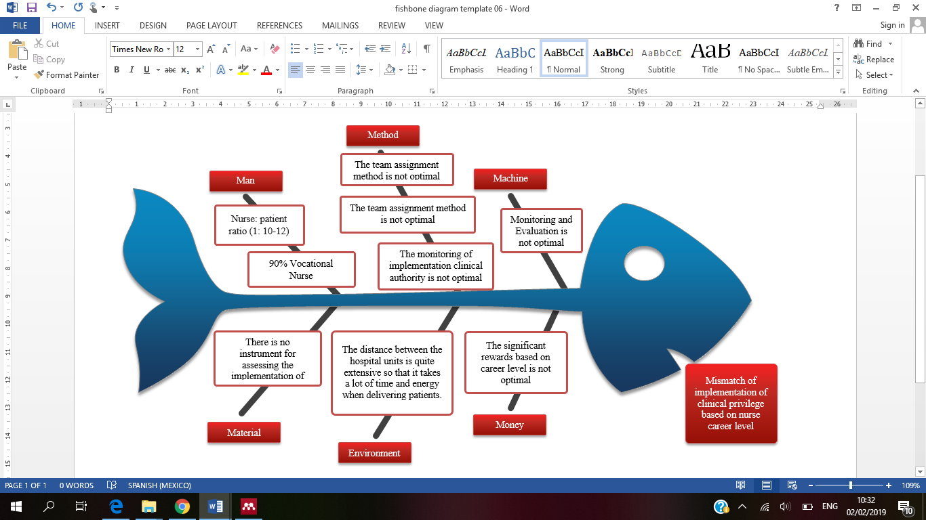

**1**. Determining root of problem: Inexpediency of implementation clinical privilege based on nurses’ career ladder by employingfishbone analysis

The result of observation is analyzed by employing fishbone diagram as shown in Picture 3. The main problem is inoptimal implementation of clinical privilege based on the level ofprofessional career of clinical nurses. The factors of this main problem are unideal ratio of nurses to patients, lack of socialization about clinical privilegefrom the boss, and lack of significant reward to the development of career level. The result of fishbone analysis becomes the foundation in arranging uncontinues plans by using management function of POSAC design started from planning, organizing, staffing, actuating, to controlling.

**IMPLEMENTATION**

The researcher continues the implementation of mini project through observation. It assesses the implementation of nursing by using Microsoft Excel modified from nursing intervention based on credential and re-credential book based on National Standard of Hospital Accreditation. It facilitates the researcher to evaluate the realization of clinical privilege implementation practiced by nurse assistantsin each clinical nurses (CN).

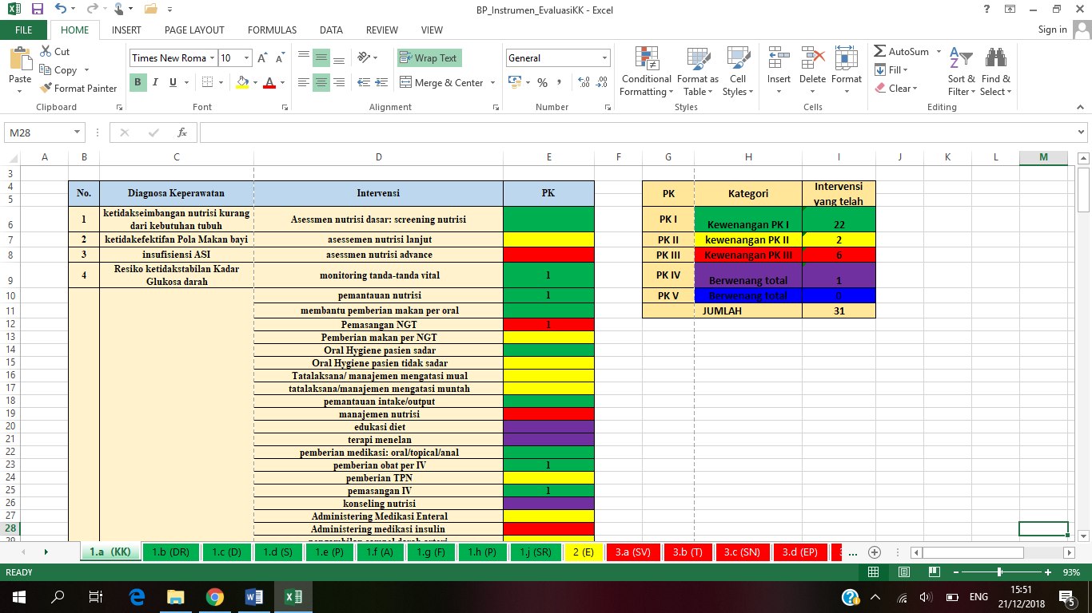

**Graph 2. Sheet 1.**

The intervention of clinical privilege based on CN level

Graph 2 is an evaluation system of clinical privilege implementation developed by the researcher. Firstly, the researcher inputs every activityon the first table containing the details of nursing intervention based on CN level. The green colour shows the clinical privilege of CN 1, the yellow colour shows the clinical privilege of CN II, and the red color shows the clinical privilege of CN III. The column on the right side is totaltoautomatically show the activities performed by Primary Nurse (PN) and CN.



**Graph 3.** An instrument developed in the assessment of clinical privilege implementation Form 2

Picture 3 is the analysis result of Picture 2 in the form of activities recapitulation performed by every nurse grouped based on the same CN level. The final result of intervention reveals that clinical nurses totally perform to every CN level. The result of recapitulation is connected to the *pie* diagram presenting the implementation of clinical privilege.

While assessing the implementation of clinical privilege in the room, the researcher joins the nurses’ team in the process of giving nursing education to investigate the implementation of nursing performed by each nurse in the room, including direct and indirect caring activities. The observation takes several days until the observation of clinical privilege implementation from all nurses in the room is achieved. The result of the observation is presented in diagram 2.

Diagram 2 shows the result of assessment on the implementation of clinical privilege performed by the nurses.CN I (72%) performs proper clinical privilege. The nurses perform several extra clinical assignments, such as 7% of clinical privilege CN II, 20% of clinical privilege CN III, and 1% of clinical privilege CN IV. Some nursing interventions frequently performed out of clinical assignment CN I are giving analgesic and antipyretic (CN II), giving oxygenlidand NGT (CN III) installation.

Furthermore, the nurses of CN III still perform nursing intervention on CN III for 13%. Nurses of CN III perform nursing intervention on CN IV for 4%. It occurs because no nurse of CN IV is in the room. However, the total intervention of CN III is less than that of CN I. It occurs because CN III performs more indirect intervention than CN I. The implementation of clinical privilege in one of military hospitals is passably conducted, though it not optimal. The hospital applies team method as the assignment method However, the researcher argues that the method is not significant. Assignment method done for extra working times of Head of Nurses is functional method.

**Planning**

Planning is the initial step and critical step to the function of nursing management 1. Planning is the first function of nursing management which becomes work principles of manager as an organizer of human resource development of nursing in a hospital. Planning is started by assessing availability of policy equipment which becomes the basis of implementing clinical privilege evaluation in inpatient rooms. Committee of Hospital Accreditation (2017) argues that a management system in a hospital enables nurses to operate well if it has services regulation in the hospital work unit. The assessment result shows that the orientation of giving clinical privilege to nurses is available.

The implementation was conducted to strengthen the basic regulation of planning which optimizes clinical privilege evaluation. The first step is arranging SOP draft of clinical privilege evaluation to the clinical nurses. This arrangementis based on the orientation of Committee of Hospital Accreditation related to arrangement orientation and SOP. The SOP is the first component compulsorily arranged as a complement to basis regulation of evaluation of clinical privilege implementation in the inpatient rooms.

**Organizing**

Organizing focuses on the nursing supervision. The result of the assessment shows that nursing supervision of clinical privilege implementation to the nurses is not performed. The assignment of implementing clinical privilege evaluation periodically is not available on the details of Head of Nurses’ job description. The implementation is to educate through interview and observation to the assignment method used.

**Staffing**

According to Gillies (1996), the function of staff development strategy and the involvement of nurses manager’s competence in the training belongs to the third function, staffing. The staffing starts with identifying availability of competent human resource of nursing to practice each level of nurses’ career. The assessment result shows that most of clinical nurses in the inpatient rooms do not possess nursing education background legitimizing them as professional nurse.

**Actuating**

Actuating is a process of forming staff’s behaviour to achieve the organization’s goal 10. The result of the assessment shows that nursing committee is a division that recommends clinical privilege to the nurses. The committee has not socialized nurses’ assignment. The conducted implementation is socializingclinical privilege orientation to the clinical nurses.

**Controlling**

The function of controlling is implemented with the evaluation of nurses’ clinical privilege implementation that becomes the aim of implementation. Controlling functions to keep the quality of organization’s achievement. The evaluation of clinical privilege implementation is conducted through observation and instrument evaluation with 3-day mentoring in the field.

**DISCUSSION**

Clinical privilege is one of the important elements in creating work circles demanding professional autonomy to increase the patients’ satisfaction and decrease tiredness and workload. The observation result shows that nurses experience 61.3% mental workload and 66.1% physical workloadcategorized as high 11. The application of clinical privilege based on career ladder becomes one of the methods to reduce the workload which potentially creates burn out to the nurses. The manager has a great role in keeping the balance of nurses’ workload, work satisfaction, and career development to create optimal nursing services.

The result of nursing problem identification in the mini project in a military hospital is the implementation of clinical privilege which has not optimally operated, and it is in line with Details of Clinical Privilege (DoCP). The observation result that strengthens this statement is that junior nurse assistants frequently receive the direct nursing assignment. It occurs since the applied assignment utilized team method. Falk & Wallin (2016) state that the weakness of team method is its unfairness to distribute workload to nurses. Consequently, it creates overburdened or stressful feeling in their job.

The implementation of clinical privilege in Hospital is no longer operated since CN I nurses perform 28% of clinical privilege which is not theirs. In addition, the head of nurses and nurse assistant state that the nursing committee does not socialize their clinical privilege based on career ladder. A foreignresearch shows that experience correlates to patients’ safety risk 12.

Nursing Legislation Number. 38, 2014 explains that nurses have competence, privilege, ethic, and high morality to give caring services conducted with responsible, accountable, qualified, safe, and affordable procedures. Clinical privilege of nursing is very important to increase patients’ satisfaction and response to the medicaltreatment, and minimize the possibility of rehospitalizing 13. In Indonesia, to take clinical privilege the nurses must take a process called credential held by nursing committee. Credential aims to increase the quality and service standard, protect patient’s safety, increase patients’ satisfaction, and provide protection to HRD and patients’ family based on clinical privilege competence given. National Standard of Hospital Accreditation in Competence and Privilege Staff (CPS) 14 declare that hospital collects credential document from medical staff licensed to provide independent caring to patients .Based on the interview result, nursing manager states that all nurses have taken credential process , so they have officially received clinical privilege through Clinical Assignment Letter (CSL) and Details of Clinical Privilege (DoCP) which signed by the director. However, the documents have not optimally socialized. Therefore, clinical nurses do not fully understand the limitation of clinical privilege they possess.

Regulation of the Minister of Health Number 49, 2013 explains that clinical privilege is the explanation of nursing intervention performed by nurses based on their practice areas. Meanwhile, clinical assignment is a hospital director’s assignment to the nurses to provide nursing care in the hospital based on clinical privilege. According to The Joint Commission International (JCI), clinical privilege is a process of determining professional skill and competence to implement diagnostic and therapeutic procedures. Clinical privilege is guaranteed for some factors, including nursing intervention, collaboration relationship, professional experiences, human resources, and rules 14.

The result of early assessment through the questionnaires indicates that 55% nurses argue that recognition to nurses’ career ladder is not optimal. Furthermore, the result of structured interviews indicates that few nursing managers state that support for the assignment and clinical privilege rises when accreditation assessment and JCI takes place. Whereas, the support of the leaders and their peers are considered as fairly good to increase the nurses’ perception on the implementation of the career ladder 15.

The implementation of clinical privilege must be optimallyconductedto ensure the patients’ safety and risk potential. Hospitals must ensure that the nurses do not conduct practices beyond their qualifications without their level of supervision. Good perception of nurses related to the importance of career ladder becomes an initial principle to create changes and improvement in conducting clinical privilege according to career ladder. The implication of residency activities is to enable students to evaluate the implementation of clinical privilege. Therefore, they can give real contribution to the hospital in practicing the function of monitoring and evaluation. The residency result can be utilized as a reference to the next researchers to identify the influence of clinical privilege implementation on the quality of nurse caring. In addition, residency result in the form of instrument can be utilized as an evaluation tool of clinical privilege to the clinical nurses that will facilitate in evaluating clinical privilege according to National Standard of Hospital Accreditation.

**RECOMENDATION**

**Nursing Committee**

Nursing committee as an authority that recommends clinical privilege to clinical nurses compulsorily conducts monitoring and evaluation to encourage the nurses implement nursing care accordance with their privileges. In addition, they should socialize credential orientation developed to nurses in all rooms.

**Nursing Department**

Nursing department as a division that plans nurses and follows up the guidance and power reduction nurses in creating the effective and efficient services should conduct an evaluation based on their professional performances. The performances is based on Competence and Privilege Staff 13 Standard, and the hospital must ensure that every nurse is competent to safely and effectively give nurses caring as autonomous action, collaboration, delegation, and a mandate to the patients .

It requires reinforcement of support and commitment from all of the elements in the hospital during the evaluation process. One of the commitments possibly conveyed is by strengthening the regulation in the form of legitimating the orientation and SPO created.

**Education**

The result of the residency is possibly utilized as a reference for the next researchers to identify the influence of clinical privilege implementation on the quality of nursing care services. In addition, residency result in the form of instrument is possibly utilized as an evaluation tool of clinical privilege to the clinical nurses that facilitates clinical privilege evaluation based on National Standard of Hospital Accreditation.

The limitation of this research is it's few involved samples and short time during the implementation of the activities ranging from planning to evaluation step. Therefore, it demands more samples involved and more time to perfect the research result.

**REFERENCES**

1. Marquis BL, Huston CJ. *Leadership roles and management functions in nursing: Theory and application*. Eight Edit. China: Wolters Kluwer Health, Lippincott Williams & Willkins, 2015.

2. Nelson JM, Cook PF. Evaluation of a career ladder program in an ambulatory care environment. *Nurs Econ* 2008; 26: 353–360.

3. Nelson KE. Nurse manager perceptions of work overload and strategies to address it. *Nurse Lead* 2017; 15: 406–408.

4. nurdiana, Hariyati SA. Penerapan Fungsi Manajemen Kepala Ruangan dalam Pengendalian Mutu Keperawatan. *J Indones Natl Nurse Assoc* 2017; 160: 1–13.

5. Haryati RTS, Igarashi, Kumiko RNP, Fujinami Y, et al. Correlation between Career Ladder , Continuing Professional Development and Nurse Satisfaction : A Case Study in Indonesia. *Int J Caring Sci* 2017; 10: 1490–1497.

6. KARS. *Standar Nasional Akreditasi Rumah Sakit*. Jakarta Selatan: Komisi Akreditasi Rumah Sakit, 2017.

7. Ezeukuw daniel N. Nurse Leader Competencies And Their Relationship To Quality.

8. Lestari, Ni Nyoman Rita, Sang Ketut Arta, SKM. M.Kes.,Ns. Ni Luh Gde Maryati SK. Hubungan komunikasi, sumber daya, sikap dan struktur birokrasi terhadap penerapan clinical privilege perawat di instalasi rawat inap dan instalasi gawat darurat. 2015; v. 3, n. 1.

9. Hittle K. Understanding Certification , Licensure , and Credentialing : A Guide For the New Nurse Practitioner. *J Pediatr Heal Care* 2010; 24: 203–206.

10. Whitehead DK, Weiss SA, Tappen RM. *Essentials of nursing leadership and management*. Fifth Edit. Philadelphia: F.A Davis Company, 2010. Epub ahead of print 2010. DOI: 10.1017/CBO9781107415324.004.

11. Wihardja H, Tutik H. Optimization Of Team Method As Efficiency Strategy Of Nurses ’ S Workload : Mini Project At Military Hospital In Jakarta Workload : Mini Project At Military Hospital In Jakarta.

12. Jewell A. Nurse Education in Practice Supporting the novice nurse to fl y : A literature review. *Nurse Educ Pract* 2013; 13: 323–327.

13. Kerzman H, Dijk D Van, Eizenberg L, et al. Attitudes toward expanding nurses ’ authority. *Journal, Isr* 2015; 1–8.

14. Hill. Position Statement on Credentialing and Privileging for Nurse Practitioners. 2016; 30: 20–21.

15. Afriani T, Hariyati RTS, Gayatri D. Dukungan Atasan Dan Teman Sejawat Memengaruhi Ekspektasi Perawat Dalam Penerapan Jenjang Karir. *J Keperawatan Indones* 2017; 20: 75.